Flight Delay and Performance Analytics System

DWV Final Report

Malak Sayed Ahmed, Faris Alaaeldin

ESLSCA 2025

## 1. Introduction

This project aims to explore and visualize patterns in airline flight performance data using a structured data analysis pipeline. The primary focus is on arrival delays, cancellations, and operational performance across U.S. carriers, routes, and dates.

## 2. Dataset Overview

* **Source**: A sample of 10,000 U.S. domestic flight records
* **File**: flights_sample_10k.csv
* **Records**: 10,000 rows
* **Attributes**: 32 columns
* **Key Columns**:
  + FL_DATE, AIRLINE, ORIGIN, DEST, DEP_DELAY, ARR_DELAY, CANCELLED, CANCELLATION_CODE, DIVERTED, DISTANCE

## 3. Data Preparation

**Tools Used:**

* **Python (pandas, matplotlib, seaborn)**
* **SQLite (via sqlite3)**
* **Tableau Public**

**Cleaning Steps:**

* Converted FL_DATE to datetime
* Dropped rows with null critical fields (DEP_DELAY, ARR_DELAY)
* Filled missing CANCELLATION_CODE with "None"
* Created DAY_OF_WEEK using Python's dt.day_name()
* Added airline names using a lookup table in SQLite
* Exported cleaned data to flights_for_tableau.csv for visualization

## 4. Data Transformation

* Categorized delays into bins using ARR_DELAY
* Extracted new columns:
  + DAY_OF_WEEK (from FL_DATE)
  + DELAYED flag (1 if ARR_DELAY > 15, else 0)
* Normalized delay metrics for ML
* Imported data into SQLite for efficient SQL querying

## 5. Analysis Process

**SQL Queries:**

* Average delay per airline
* Top 10 most delayed routes
* Cancellations by reason
* Delay patterns by weekday
* Diverted vs. non-diverted flights

Queries were documented in analysis_queries.sql.

**Python EDA:**

* Histograms of delay distribution
* Boxplots of delay by airline
* Bar charts of delay by day
* Random forest classifier for predicting delays

## 6. Tableau Visualizations

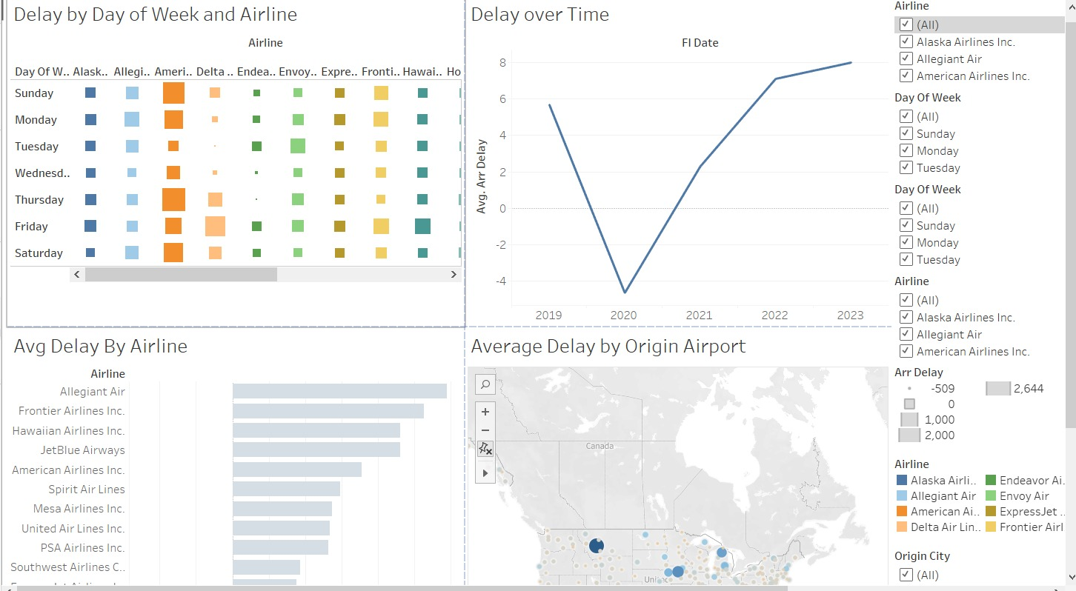

## Key Charts:

* **Bar Chart**: Average Delay by Airline

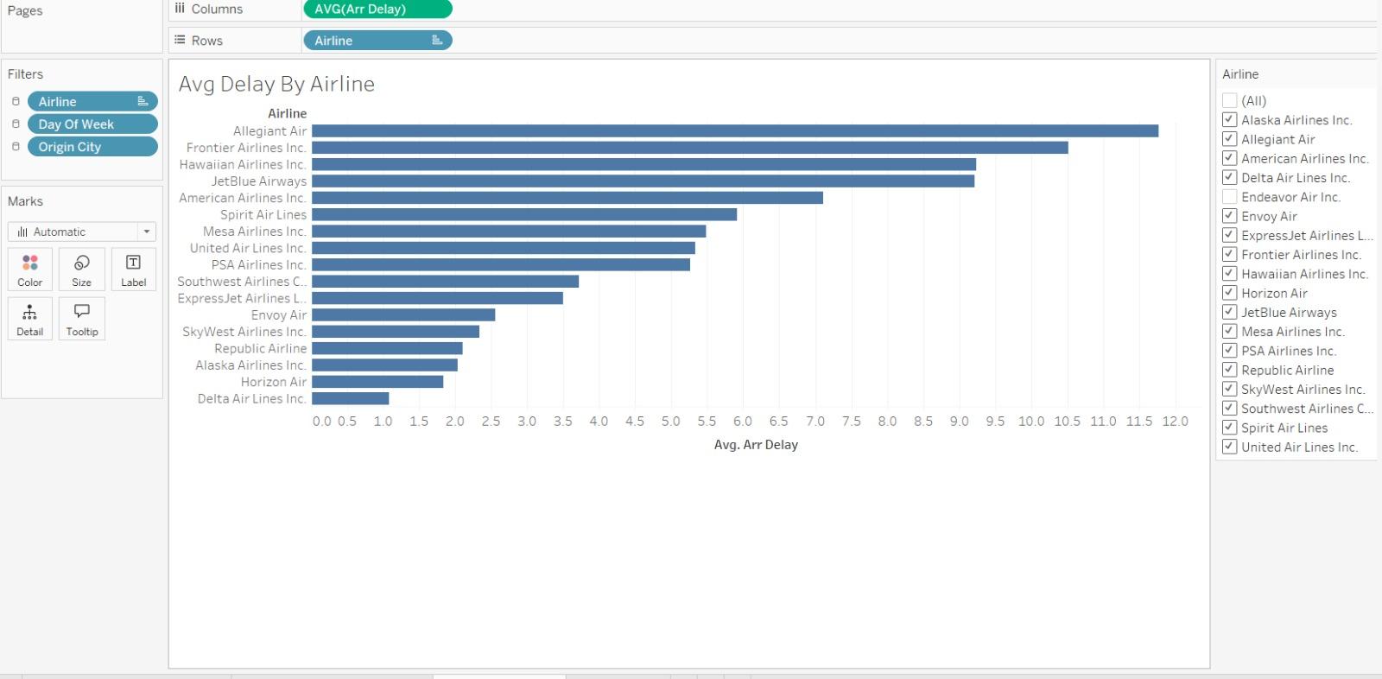

* **Line Chart**: Average Delay Over Time

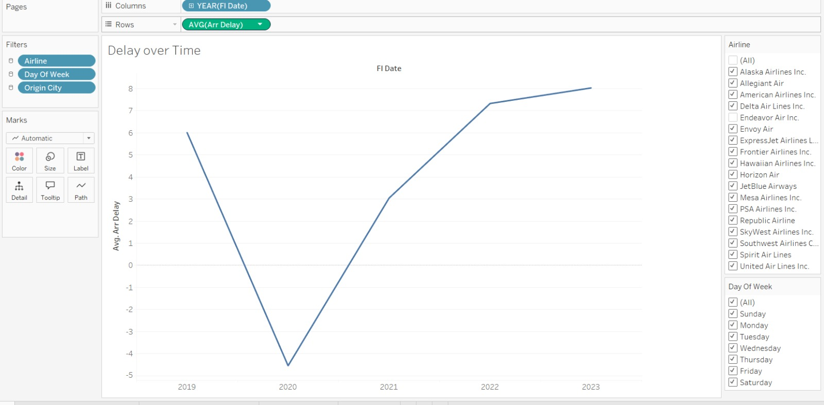

* **Heatmap**: Delay by Airline and Day of Week

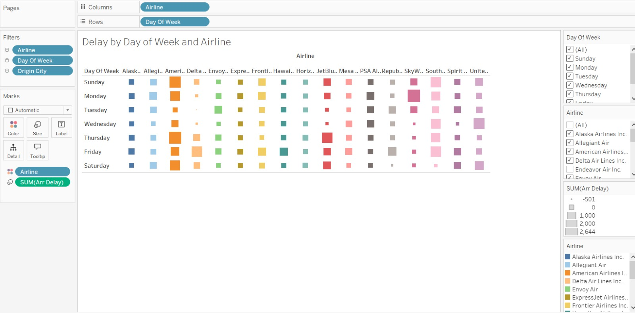

* **Map**: Average Delay by Origin Airports

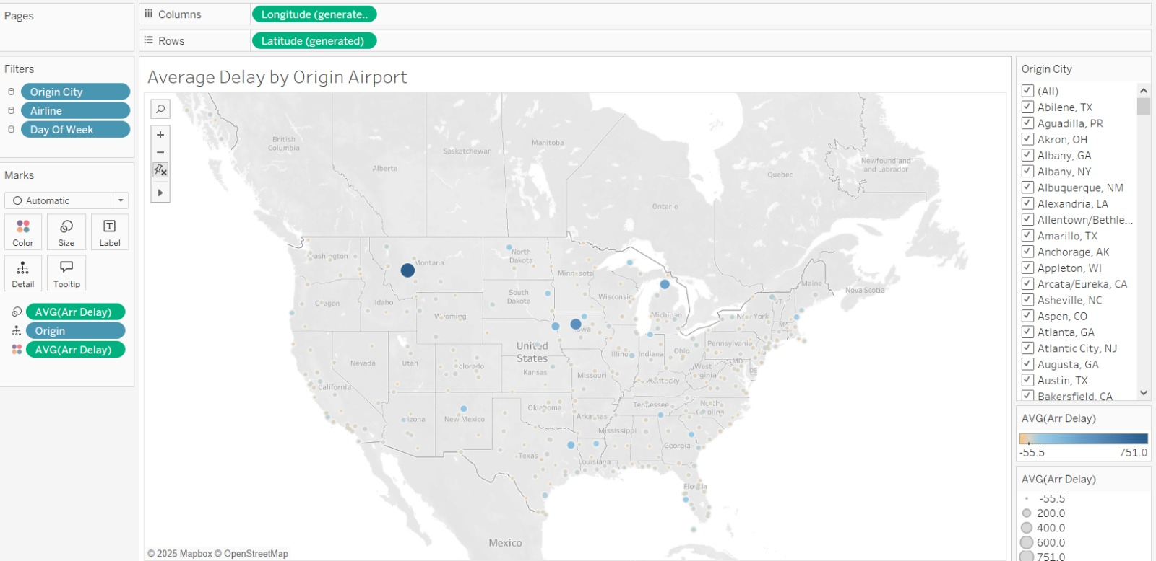

## 7. Insights & Findings

* **Airline ATL** had the worst average delays, while **Airline Horizon Air** was most punctual
* **Thursday** and **Sunday** showed higher average delays than midweek
* Most cancellations were coded as "A" (Carrier-related)
* Some airports (like ORD and ATL) consistently had longer delays
* A basic classifier was able to predict delays using DEP_DELAY and DISTANCE with 95% accuracy

## 8. Deliverables Summary

|  |  |
| --- | --- |
| File | Description |
| cleaned_flights.csv | Cleaned dataset for analysis |
| flights.db | SQLite DB with both flights and airlines tables |
| analysis_queries.sql | Documented SQL queries |
| flights_for_tableau.csv | Tableau-ready export with airline names |
| flights_analysis.py | Python script for wrangling, EDA, and ML |
| dashboard.twbx | Tableau workbook file |
| *Screenshots* | For final presentation and report |

## 9. Conclusion

This project demonstrates a full data analysis lifecycle: collecting, cleaning, transforming, analyzing, and visualizing real-world airline data. Tableau provided a powerful platform to communicate the results in an interactive and visual way, enabling insights into operational reliability and areas for improvement in airline services.